NAME : | BHAVYA JAPPI | DATE : | 07-08-2026
AGE/SEX : | 22 YRS MALE
REF BY Dr : | RONAK SHAH

X-RAY:RIGHT ELBOW JOINT (AP/LATERAL VIEWS)

The bones of the right elbow joint show normal alignment and mineralization.

There is no evidence of obvious fracture. No focal sclerotic or lytic lesion noted

The joint spaces and articular margins are normal.

There is no soft tissue abnormality.

IMPRESSION:

- No significant abnormality detected.

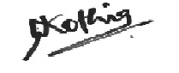
DR. NIKUNJ KOTHIA
CONS. RADIOLOGIST

